**A**

**Field Training/Internship/Industrial Training Report**

**On**

**“Web Development”**

**Submitted in Partial Fulfilment of Requirement for the Award of Degree of**

**BACHELOR OF TECHNOLOGY**

**(Computer Science & Engineering)**

**Of**

**Dr. Babasaheb Ambedkar Technological University, Lonere**

**Submitted By,**

**Ms. Jui G. Arde PRN No: 1967971242017 Btech**

**Under the Guidance of,**

**Ms. N. J. Waragde [Assistant Professor]**



Raosaheb Wangde Master Charitable Trust's

**Dnyanshree Institute of Engineering & Technology**

**Sajjangad Road, Satara, Maharashtra State, 415 013, (India)**

**2022-2023**

**CERTIFICATE**

This is to certify that the Field Training/Internship/Industrial Training entitled, “**Web Development**” is

**Submitted by**

**NAME OF STUDENT PRN**

Ms. Jui G. Arde 1967971242017

As per the Field Training/Internship/Industrial Training Certificate submitted by student is a bonafide work carried out by the student under the guidance of Industrial Training Co-ordinator Asst. Prof. N. J. Waragde. It has been accepted and approved for the partial fulfilment of the requirement of,

**Dr. Babasaheb Ambedkar Technological University, Lonere**

For the award of the degree of Bachelor of Engineering (Computer Science and Engineering). This work and Field Training/Internship/Industrial Training has not been earlier submitted to any other Institute or University for the award of any degree or diploma.

N. J. Wargde Dr. V. K. Bhosale Dr. A. D. Jadhav

**[Industrial Co-ordinator] [Head of Department] [Principal]**

**Place: Satara**

**Date:**

**ACKNOWLEDGEMENT**

We take this opportunity to express our gratitude to “Dnyanshree Institute of Engineering And Technology Sajjangad, Satara.” For sanctioning us the Field Training/Internship/Industrial Training on

**“Web Development”**

And for allowing access to various facilities in this institute. We are extremely grateful to Hon. R.D.Wangde (Managing Director), Dr. A.D.Jadhav (Principal) of our college for extending all facilities to us for smooth progress of our industrial work. We wish to express our heartily thanks Dr. V. K. Bhosale Head of Department of “Computer Science Enginerring”. Co-ordinator Ms. N. J. Waragde (Assistant Professor) for encouragement & guidance towards completion of our Field Training/Internship/Industrial Training. We would also like to express our sincere respect to other teaching & non- teaching staffs. Last but not the least we would like to thank all our friends, who helped us directly or indirectly.

Finally we admit that co-operation & co-ordination were our keywords to success.

**Ms. Jui G. Arde**

**(1967971242017)**

**B-tech**

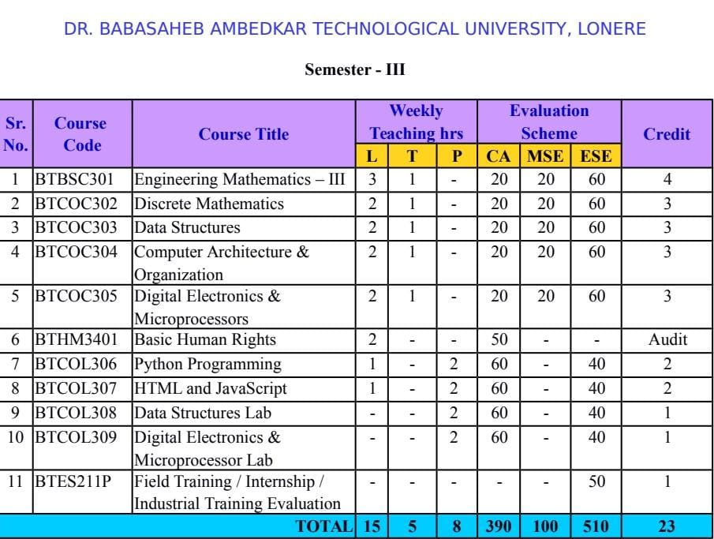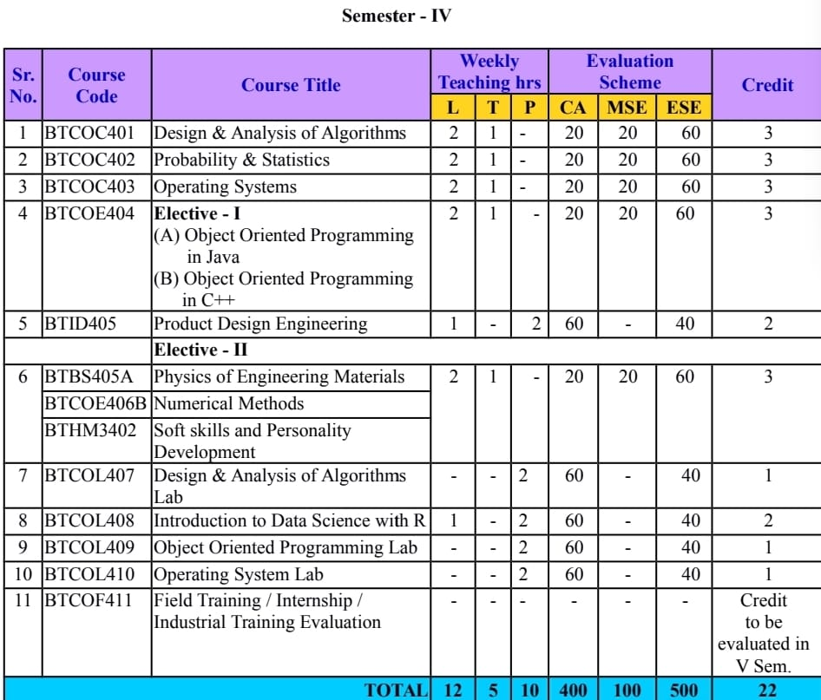

EXECUTIIVE SUMMARY

This is an internship report, undertaken from Internshala Platform.The intern started from 09 September 2021. At the Dnyanshree Institute of Engineering & Technology, Satara. It is mandatory for students to have a minimum of two (2) weeks practical industrial experience in their respective fields of training and organization of their choice. An Industrial attachment is essential requirement for awarding of Bachelor Degree Certificate in the Dnyanshree Institute of Engineering & Technology, Satara.

The purpose of the internship is to prepare the student to serve the needs of industry and commerce more effectively upon graduation. This included providing real life experience and exposure, thus gaining first-hand exposure of working in the real world, granting the opportunity to learn more about the intern self-potentials and abilities, getting connected and developing professional network, preventing CV from going to trash during job application and transition to full-time job position. Internship allows students to harness the skill, knowledge and theoretical practice they learnt in the university and enabling them to transform theory into practical real life situations. The intern’s time with Internshala has really illuminated his knowledge and understanding of practical experience of the theories being taught between the walls of the University lecture halls and in the corporate environment.

**Industrial Training Certificate**

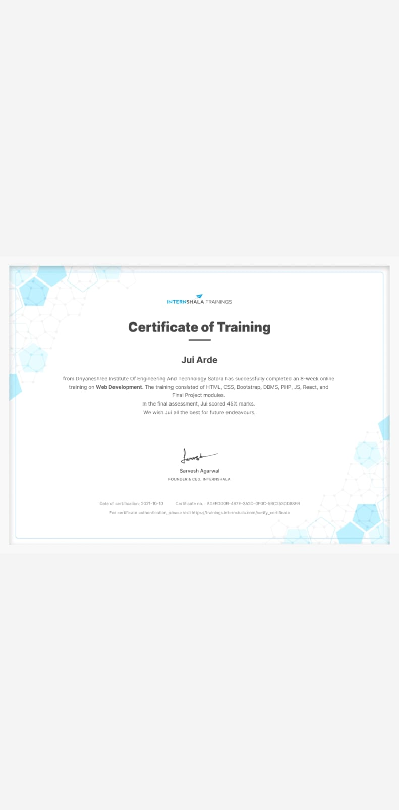

**CONTENTS**

|  |  |  |
| --- | --- | --- |
| **Chapter No.** | **Title** | **Page No.** |
|  | Title Page | 1 |
|  | Certificate | 2 |
|  | Acknowledgement | 3 |
|  | Executive Summary | 5 |
|  | Contents | 7 |
| 1 | Introduction |  |
|  | 1.1 Introduction | 9 |
|  | 1.2 Industrial Training objective | 9 |
|  | 1.3 Importance | 10 |
| 2 | Background of the Report |  |
|  | 2.1 Background of the Report | 11 |
|  | 2.2 Terms of Reference | 12 |
|  | 2.3 Purpose of Attachment/Expected Output | 13 |
| 3 | Profile of the Organization | 14 |
|  | 3.1 Profile of the Organization | 14 |
|  | 3.2 Background | 14 |
|  | 3.3 Mission | 14 |
|  | 3.4 Vision | 14 |
|  | 3.5 Values | 14 |
|  | 3.6 Awards | 15 |
| 4 | Field of Experience | 16 |
|  | 4.1 Field of Experience | 17 |
|  | 4.3 Work | 18 |
|  | 4.3.1 Assigned Work | 18 |
|  | 4.3.2 Technical Requirement | 18 |
|  | 4.3.3. Technologies Used | 18 |
|  | 4.3.5 Work Output | 19 |
| 5 | Lesson Learnt | 21 |
| 6 | Challenges | 23 |
| 7 | Conclusion | 25 |

**CHAPTER No.1**

**INTRODUCTION**

This chapter organized as, section 1.1 describes introduction of the industrial Training and section 1.2 Industrial Training objectives and Section 1.3 describes Importance of industrial Training.

* 1. **Introduction:**

The purposes of the internship are to prepare the student to serve the needs of industry and commerce more effectively upon graduation. This included providing real life experience and exposure, thus gaining first-hand exposure of working in the real world, granting the opportunity to learn more about the intern self-potentials and abilities, getting connected and developing professional network, preventing CV from going to trash during job application and transition to full-time job position. Internship allows students to harness the skill, knowledge and theoretical practice they learnt in the University and enabling them to transform theory into practical real life situations.

**1.2 Industrial Training objectives:**

* To improve job performance by extending knowledge & skills to work in the most economical, efficient and satisfying way in engineering organization in future
* Understand role of an engineer in an engineering organization/company.
* Enrich practical and technical skills. (Critical analysis, logical thinking, learning and working on latest technology etc.).
* Understand importance of the teamwork.
* Training them to communicate & interact with workers &other professionals
* Learn the real life working culture.
* Become aware about contemporary issues, community expectations and ethics followed by an Industry.
* Learning to work in professional behavior.
* Observing the various operations in a company/ organization.
* Doing work in actual practice.
* Visual observations of problem diagnosis & action taken.
* Communication with workers & other professionals
  1. **Importance:**
* Industrial Training is the most important strategy to expose students to real work life situations and to equip them with the necessary skills that intensify their job.
* The industry introduction increases the undergraduate’s work life through added eagerness and responsibility by giving a long lasting learning experience.
* It gives an opportunity to engage with the profession to which they aspire in a realistic work environment.
* Provides opportunity to work with professional mentors and to begin to build networks within their profession.
* It improves the ability to acquire and apply fundamental principles of science and engineering and capabilities to communicate effectively.
* Ability to conduct research in the chosen fields of engineering.
* Understanding of the importance of sustainability and cost-effectiveness in design and developments of engineering solution.
* Ability to be a multi-skilled engineer with good technical knowledge, management, leadership and entrepreneurship skills.
* Makes awareness of the social, cultural, global and environment responsibility as an engineer.
* Capability and enthusiasm for self-improvement through continuous professional development and life-long learning.

**CHAPTER No.2**

**BACKGROUND OF THE REPORT**

This chapter organized as, section 2.1 describes background of the report and section 2.2 describes the Terms of Reference and Section 2.3 describes the Purpose of Attachment/Expected Output.

**2.1 Background of the Report:**

As a part of my S.Y. B-Tech Bachelor’s Degree studies in Computer Engineering as per the requirement of the Dnyanshree Institute of Engineering & Technology, Satara. [Dr.Babasaheb Ambedkar Technological University, Lonere] it is mandatory the academic year to perform an internship. Students being degree or diploma are to embark on this internship for minimum of two weeks to enable them obtain practical industrial experience in the field of study and also to abreast themselves of the business environment. The report is written at the end of the internship by the student to the institute which form part in the awarding of the degree certificate. The intern did a 6 week internship from 08 September, 2021 to 10 Octomber 2021 at Internshala.

An internship is an extensive program through which an intern can learn the practical aspects of what is taught Online. The internship help students to learn, know and understand what actually happen on the field as compared to what they have studied in the college. This is a report on the purpose of carrying out the internship, the profile of the chosen organization of the intern, duties and schedules performed in the organization, the contributions of the intern to the organization, application of theories to real –life situations, various lessons learnt by the intern, challenges encountered, conclusions drawn and recommendations made by the intern.

## 

## **2.2 Terms of Reference:**

In accordance to the Dr. Babasaheb Ambedkar Technology University, Lonere (DBATU), as part of it academic policy for every student, at the 1st Year, the university place students with various business organizations for a minimum period of two weeks to enable them obtain practical industrial experience in their respective field of training and also to submit a written report after the internship. The internship report entails areas such as purpose of attachment, profile of the organization or institution, contribution of student to organization, application of theories to real life situation, challenges faced and lessons learnt from the organization as well as recommendations from students.

## **2.3 Purpose of Attachment/Expected Output:**

By the requirements of the University Of Professional Studies, Accra (UPSA) to the award of degree and diploma certificates, it is a pre-condition that every student upon moving to the final year undertakes an industrial attachment with a selected organization of their choice. The internship provides students the opportunity to gather some work experience relevant to their studies and their professional work field. It helps the student to learn discipline and principles of working ethics.

The following are the purposes of the internship:

* An internship provides a real life experience and exposure. It enables the intern to gain first-hand exposure of working in the real life which is remarkably valuable towards the intern’s career.
* It allows the student to harness the skill, knowledge and theoretical practice been taught in the university. To provide the students with an opportunity to apply the knowledge in real work situation thereby closing the gap between academic work and the actual practice.
* Internship teaches young professionals about specific industries and companies they are interested in, projects their self-potentials, abilities and shortcoming.
* Get connected; develop professional network and transition to full-time position.

**CHAPTER No.3**

**3.1 Profile of the Organization:**

Internshala is an internship and online training platform. Founded by [Sarvesh Agrawal](https://en.wikipedia.org/w/index.php?title=Sarvesh_Agrawal&action=edit&redlink=1), an [IIT Madras](https://en.wikipedia.org/wiki/IIT_Madras) alumnus, in 2011, the website helps students find [internships](https://en.wikipedia.org/wiki/Internship) with organisations in India.

**3.2 Background:**

Internshala is a web-based platform that provides internship resources and career services to students and employers. The platform offers internship searching and posting services as well as many other career services such as counseling, cover-letter writing, resume building, and training programs to students.

**3.3 Mission:**

With an insight that more than 90% of the graduates in India start their careers with a job that pays less than 3LPA, we came up with Placement Guarantee courses to help the students start their careers in their dream profiles.

**3.4 Vision:**

We are a technology company on a mission to equip students with relevant skills & practical exposure to help them get the best possible start to their careers. Imagine a world full of freedom and possibilities. A world where you can discover your passion and turn it into your career. A world where you graduate fully assured, confident, and prepared to stake a claim on your place in the world.

**3.5 Values:**

##### **PASSION-** Whatever we do, we do it from the bottom of our heart.

##### **RESPECT-**We respect those who add value to our lives.

##### **INTEGRITY-**We never compromise on our values.

##### **COLLABORATION-**We believe in working towards a unified goal.

##### **OWNERSHIP-**We are responsible for all our actions.

##### **LISTEN-**We listen to both the spoken and unspoken before we act.

**3.6 Awards:**

* In 2011, the website became a part of NASSCOM 10K Startups.
* In 2015, Internshala was a finalist in [People Matters](https://en.wikipedia.org/wiki/People_Matters) TechHR 2015 Spotlight Awards under 'Futurism in Recruitment' category.

**CHAPTER No.4**

**FIELD OF EXPERIENCE**

1. **Field Of Experience:**

During the internship period, It was great to learn new things. In this we have given the tasks to complete which were very intresting to do. Learned a lot of things.

**4.3.1 Assigned Work:**

To solve all the assignments and design a website using HTML & CSS.

[**4.3.2 Technical Requirement:**](https://docs.google.com/forms/d/e/1FAIpQLSc8KDsg4ygm_S_Psxz6setiQi1wnuEzrMSwUuv-aUDJOu5Wkg/viewform?vc=0&c=0&w=1)

Laptop with any OS, Internet connection

**4.3.3 Technologies Used:**

HTML  
CSS  
BOOTSTAP  
XAMP  
PHP

**4.3.4Work Output:**

* I got Experience about how to design a website.
* Making the good product, in minimum needs.

**CHAPTER No.5**

**LESSONS LEARNT**

# 5.1 Lessons Learnt:

During the internship the intern learn the following lessons:

* The intern now has good understanding of Web Development.
* Strong HTML CSS Skills.
* Usability Comes First Always.
* Planning and Preparing of Documentation.
* Needs Change With Time.

**CHAPTER No.6**

**CHALLENGES**

# 6.1 Challenges:

Browser and platform compatibility are typically one of the biggest challenges for web developers. Therefore, you need to make sure the sites work on all the existing browsers on the internet and devices of different screen sizes. Achieving maximum loading speed for a website is a crucial challenge for any web development. Scaling websites is about sustainable performance, whether it’s 10 users per minute or 100 visitors per minute.

All these challenges has helped the intern to gain valuable work experience and real life exposure. It also allowed the student to harness the skill, knowledge and practice been taught in the trainings.

**CHAPTER No.7**

**CONCLUSION**

1. **CONCLUSION:**

Web development process consists of several stages, starting from understanding client’s needs, deep research and analysis to design, development and beyond. And sometimes, it can be a time-consuming and daunting task. But thanks to the immense resources across the internet. There are many blogs and tutorials helping owners to dive deep into this process. Even there are seasoned web development companies catering services to the clients.